**Scenario**

You are hired to develop a normalized data model starting with a sample document (see table below). The sample document is a digital bill summary sheet that Orange Digital Company is currently using to track the telephone, internet connection, and cable usage for its customer accounts. Orange Digital Company wants to build a small database to store and retrieve this information.

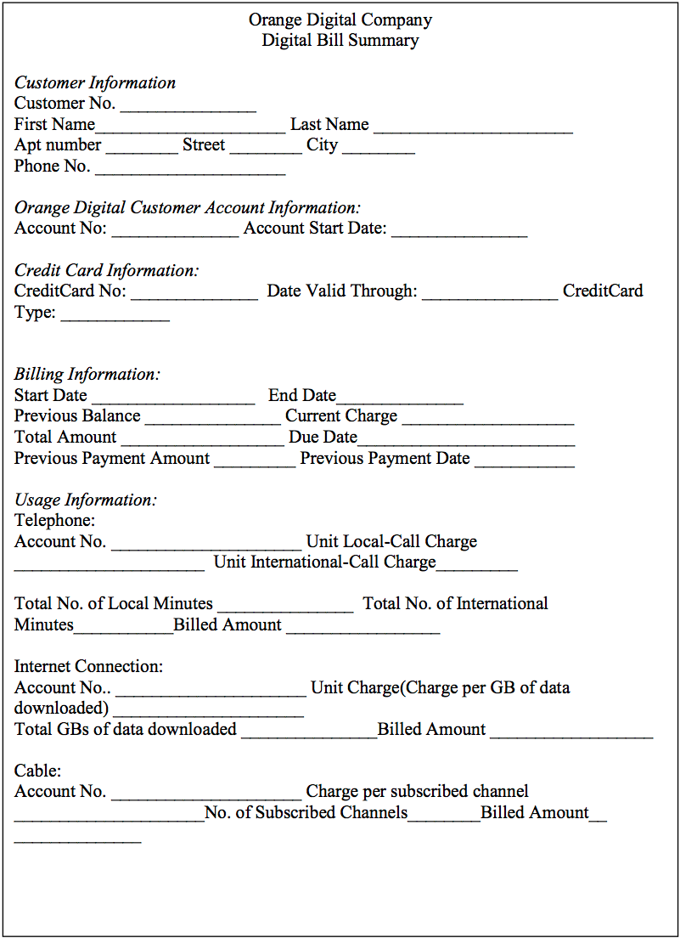

Business Rules:

1. Each customer must have at least one account with Orange Digital Company.
2. Each customer must have at least one credit card for bill payment.
3. Each account must have at least one of the connections, e.g., telephone/internet / cable.
4. Telephone account number is not the same as Internet connection account number or cable account number.
5. Each telephone account number is associated with one and only one customer account number.
6. Each internet connection account number is associated with one and only one customer account number.
7. Each cable account number is associated with one and only one account number.
8. Current charge is the summation of telephone, internet connection and cable billed amounts for the billing period. There are no adjustments from previous cycles.

**Solution:**

**Step 1: Start with 1 NF**

**Criteria**:

* Every column has unique name.
* Every row is unique.
* Every value is atomic.
* Composite Key: **CustomerNo** (Customer No)**, ODCAccountNo** (Orange Digital Customer

Account No)**, BStartDate** (Billing Start Date)

**Data Sheets:**

Orange Digital Company

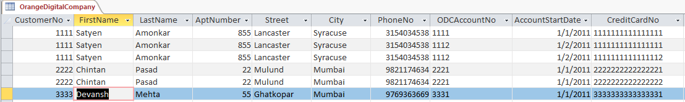

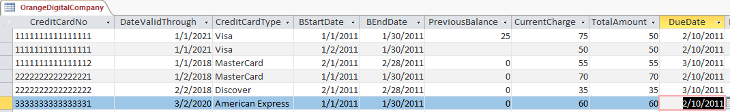

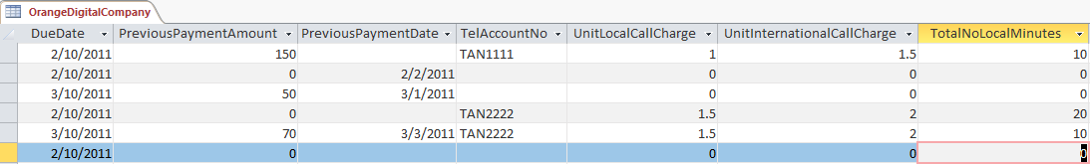

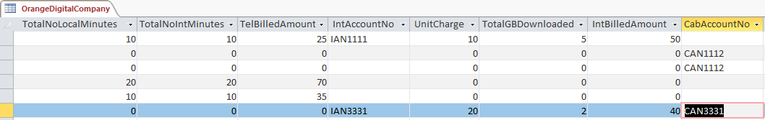

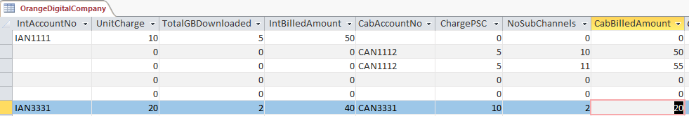

**Relationships**:

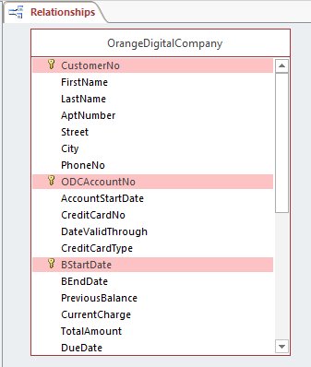

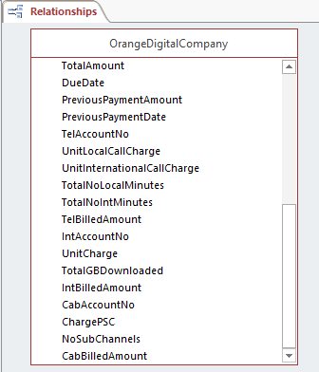

**Step 2: Creating the 2nd NF**

**Criteria**:

* Every non-key attribute(non PK and FKs) must be defined by the Primary Key (PK), not only part of the PK. i.e. Removing Partial Functional Dependencies

Partial Dependencies:

1. FirstName, LastName, AptNumber, Street, City, PhoneNo are partially dependent on primary key **CustomerNo**. (Customer Information)
2. AccountStartDate is partially dependent on primary key **ODCAccountNo**. (Orange Digital Customer Account Information)
3. BEndDate, PreviousBalance, CurrentCharge, TotalAmount, DueDate, PreviousPaymentAmount, PreviousPaymentDate, TelAccountNo, UnitLocalCallCharge, UnitInternationalCharge, TotalNoLocalMinutes, TotalNoIntMinutes, TelBilledAmount, IntAccountNo, UnitCharge, TotalGBDownloaded, IntBilledAmount, CabAccountNo, ChargePSC, NoSubChannels, CabBilledAmount are partially dependent on primary keys **ODCAccountNo**, **BStartDate**. (Billing Information and Usage Information)
4. CreditCardNo, DateValidThrough, CreditCardType are dependent on the complete composite key i.e. **ODCAccountNo**, **BStartDate**, **CustomerNo.** (Credit Card Information)

**Removing Partial Dependencies:**

1. Since Customer Information is only dependent on CustomerNo, removed the partial dependency by creating a new table i.e. Customer. (**3NF**)
2. Since Orange Digital Customer Account Information is only dependent on ODCAccountNo, removed the partial dependency by creating a new table i.e. ODCAccount. (**3NF**)
3. Since Billing Information and Usage Information are dependent on both ODCAccountNo and BStartDate, removed the partial dependency by creating a new table i.e. BillingPayment. (**3NF**)
4. Since Credit Card Information is dependent on ODCAccountNo, BStartDate and CustomerNo, there is no partial dependency. Created table CreditCardRecords to store this information. (**2NF**)
5. Mapped the 1:M relationship between Customer & ODCAccount using foreign key at ODCAccount (CustomerNo).

**Data Sheets:**

Customer (3NF)

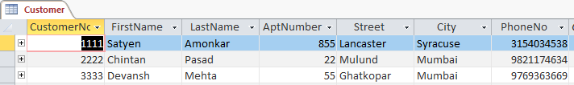

ODCAccount (3 NF)

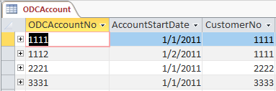

BillingPayment (3NF)

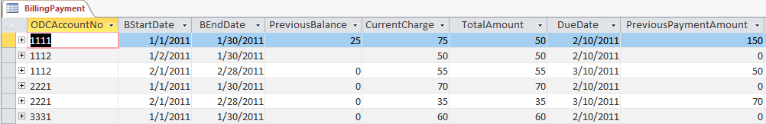

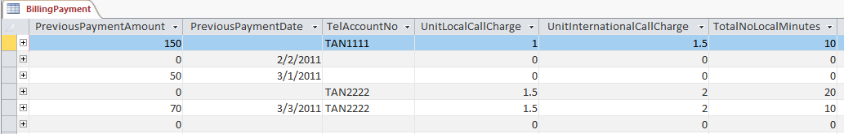

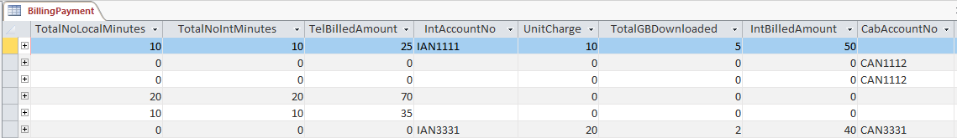

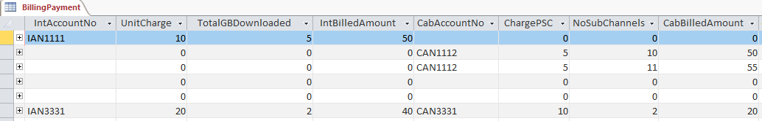

CreditCardRecords (2 NF)

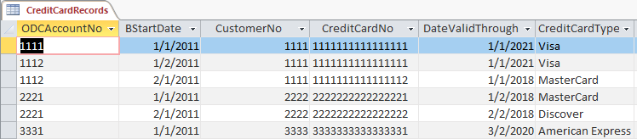

**Relationships:**

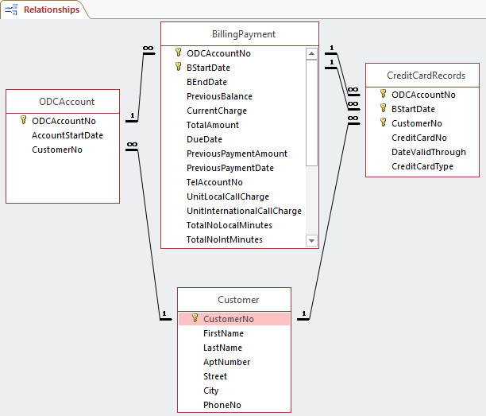

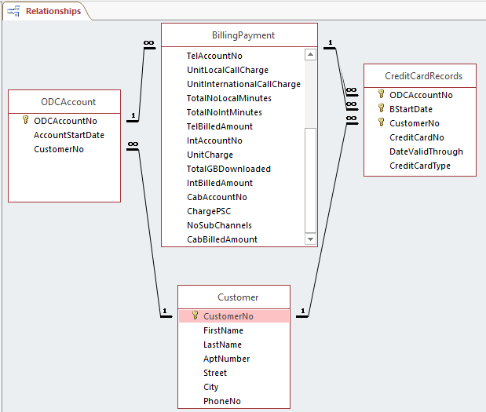

**Step 3: Creating the 3rd NF**

**Criteria**:

* Removing Transitive dependency such that each attribute must be dependent on the **entire PK only.**

**Transitive Dependencies**:

1. DateValidThrough, CreditCardType -> CreditCardNo (DateValidThrough and CreditCardType have Transitive Dependency over CreditCardNo)
2. CreditCardNo -> **ODCAccountNo**, **BStartDate**, **CustomerNo** (CreditCardNo has Transitive Dependency over ODCAccountNo, BStartDate, CustomerNo)

Therefore: DateValidThrough, CreditCardType -> **ODCAccountNo**, **BStartDate**, **CustomerNo** (DateValidThrough, CreditCardType have Transitive Dependency over ODCAccountNo, BStartDate, CustomerNo)

**Removing Transitive Dependencies:**

1. Creating a new table, CreditCardDetails for the transitive dependency.
2. Keeping the non-key attributes that are determined by the entire PK untouched.
3. Assigning CreditCardNo as primary key for CreditCardDetails.
4. Assigning CreditCardNo as foreign key for CreditCardRecords.
5. BillingPayment cannot be further normalized as all the attributes are functionally dependent on ODCAccountNo and BStartDate.

**Final 3 NF Data Sheets:**

**CreditCardRecords** (3 NF)

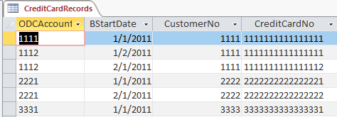

**CreditCardDetails** (3 NF)

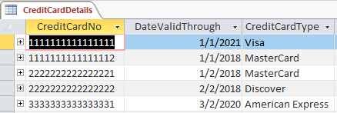

BillingPayment (3NF)









Customer (3NF)



ODCAccount (3 NF)



**Final 3 NF Relationships:**

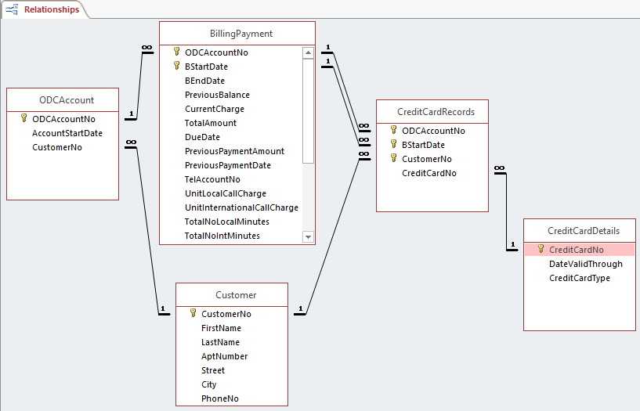

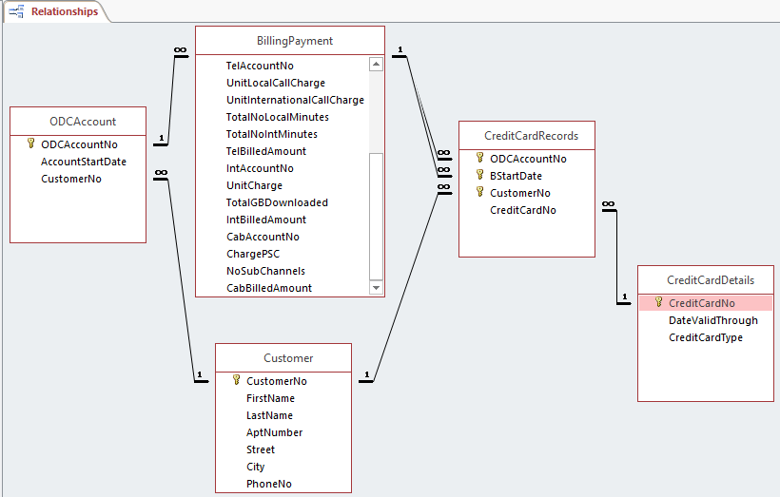

The final database design consist of 5 3NF tables: ODCAccount, Customer, BillingPayment, CreditCardRecords and CreditCardDetails.